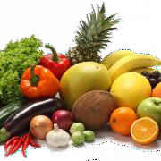
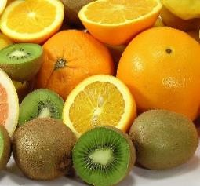
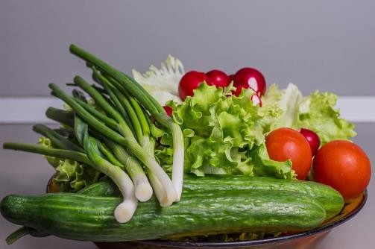
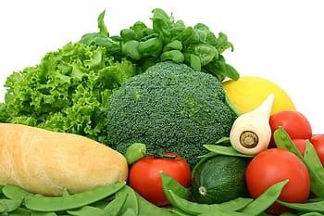
Exmoor Link Federation
Menu October 2025 – April 2026

 |  | Week 1 | Week 2 | Week 3
Week Commencing: |  | 3rd Nov, 24th Nov, 15th Dec, 19th Jan, 9th Feb, 9th March,  30th March. | 10th Nov, 1st Dec, 5th Jan,  26th Jan, 23rd Feb, 16th March. | 17th Nov, 8th Dec, 12th Jan,  2nd Feb, 2nd March, 23rd March.
Monday | A B  C | Chicken Burger in a Bun Vegetable Burger in a Bun With Seasoned Wedges & Baked Beans | Pasta Bolognese with Garlic Bread  Quorn Bolognese with Garlic Bread | West Country Sausages Quorn Sausages  With Creamy Mashed Potatoes & Beans
 | A B  C | Jacket Potato with a selection of fillings | Jacket Potato with a selection of fillings | Jacket Potato with a selection of fillings
 | A B  C | Pancakes, Bananas & Ice Cream. | Jelly, Peaches & Cream | Chocolate Ice Cream with a Wafer
Tuesday | A B  C | Cottage Pie | Sweet and Sour Chicken Balls | Hunters Chicken
 | A B  C | Quorn Pie  With Seasonal Mixed Vegetables | Quorn Chicken Balls  With Egg Fried Rice | Mixed Bean Chilli  With Rice & Sweetcorn
 | A B  C | Jacket Potato with a selection of fillings | Jacket Potato with a selection of fillings | Jacket Potato with a selection of fillings
 | A B  C | Carrot Cake | Pineapple upside Down Cake with Cream | Banana & Blueberry Muffin
Wednesday | A B | Roast Chicken with Stuffing  Quorn Fillet  With Roast Potatoes, Seasonal Vegetables and Gravy  Chocolate Brownie | Roast Pork with Apple Sauce  Vegetable & Lentil Crumble With Roast Potatoes, Seasonal Vegetables and Gravy  Sticky Toffee Pudding | Roast Beef with Yorkshire Pudding  Homity Pie  With Roast Potatoes, Seasonal Vegetables and Gravy  Eton Mess
Thursday | A B  C | Pork Meatballs | Mild Chicken Curry | Beef Lasagne
 | A B  C | Veggie Meatballs  With Mediterranean Tomato Sauce and Pasta | Sweet Potato Curry Bites  With Rice, Peas & Naan Bread | Vegetable Lasagne  With Garlic Bread and Coleslaw
 | A B  C | Jacket Potato with a selection of fillings | Jacket Potato with a selection of fillings | Jacket Potato with a selection of fillings
 | A B  C | Raspberry Sponge with Pink Custard | Jam & Coconut Sponge with Custard | Toffee Apple Crumble with Custard
Friday | A B  C | Cod Bites  Vegetarian Sausage Roll  With Chips & Beans | Oven Baked Fish Cake Cheese and Tomato Pizza With Chips & Salad | Oven Baked Cod Fish Fingers Crispy Battered Vegetables With Chips & Peas
 | A B  C | Jacket Potato with a selection of fillings | Jacket Potato with a selection of fillings | Jacket Potato with a selection of fillings
 | A B  C | Short Bread Biscuit | Flapjack | Oat Biscuit

